STATE OF WASHINGTON
TELECOMMUNICATIONS SERVICE PRIORITY (TSP) PLAN

I. PURPOSE

The purpose of this planning guide is to describe the State of Washington's policy and procedures for the Telecommunications Service Priority (TSP) system. It summarizes the legal and regulatory basis and procedures for all non-federal government agencies in Washington (including public medical facilities). It will aid potential users in determining eligibility for TSP and outlines the procedures for submitting TSP applications in Washington.

II. OBJECTIVE

The objective of this plan is to provide guidance to users on identifying TSP requirements, submitting applications for TSP, and implementing TSP.

III. REFERENCES

This plan contains information from various sources. Local governments should get a copy of CPG 1-18, "Guidance for Telecommunications Service Priority System" for a complete description of the system before determining their eligibility for TSP. National Communications System (NCS) Manual 3-1-1, another excellent reference, is available from the Superintendent of Documents, Washington, D.C. 20402 or from the NCS home page at http://www.ncs.gov/tsp/

A. Title 47 CFR, Part 64, Appendix A, "Telecommunications Service Priority (TSP) System for National Security Emergency Preparedness (NSEP)."

B. Federal Emergency Management Agency (FEMA) Civil Preparedness Guide (CPG) 1-18, "Guidance for Telecommunications Service Priority System", July 1992.

C. NCSD 3-1, "Telecommunications Service Priority (TSP) System for National Security Emergency Preparedness (NSEP)", July 5, 1990.

D. NCS Manual 3-1-1, "Telecommunications Service Priority (TSP) System for National Security Emergency Preparedness (NSEP), July 9, 1990.

E. "National Plan for Telecommunications Support in Non-Wartime Emergencies", prepared in coordination with the member organizations of the Joint Telecommunications Resources Board and approved by the Director, Office of Science and Technology Policy, Executive Office of the President, January 1992.

IV. TSP SYSTEM OVERVIEW

The TSP System is a priority based system for the installation of new telecommunications services which may be needed during a national emergency or disaster, as well as the restoration of TSP identified telecommunications services at any time. The Federal Communications Commission (FCC) established the TSP System on November 17, 1988. Concurrently, the Executive Office of the President issued National Communications System Directive 3-1, directing all federal agencies to participate in this system. Telecommunications services eligible for TSP must meet the National Security Emergency Preparedness (NSEP) criteria defined in NCS 3-1 and FEMA CPG 1-18. In late 1989, the FCC authorized and required telecommunications vendors to use it with full implementation to begin on March 1993.

The FCC provides regulatory oversight of the TSP System, enforces regulations, and provides final approval authority for assignments. The Manager, National Communications System (NCS), Office of Priority Telecommunications (OPT) administers the system on behalf of the President.

The TSP System replaces the FCC Restoration Priority (RP) System. RP applied only to the restoration of "federal" inter-city private line circuits. The TSP System encompasses providing and restoring services to a broader range of federal communications systems. In replacing the RP system, TSP allows for participation by federally sponsored state and local government users. Additionally, TSP incorporates administrative requirements to ensure accuracy of records. State and local governments may have telecommunications services that qualify for TSP treatment. Private industry/business services may qualify as well. However, only a small percentage of telecommunications services qualify as NSEP services.

All potential NSEP service users must meet certain qualifications to be part of the system. State and local governments may submit applications for TSP assignments for restoration priority directly to the NCS, Office of Priority Telecommunications (OPT). Requests for restoration priority should be requested in advance of any emergency or disaster. Requests for provisioning new service following an emergency or disaster must be submitted for authorization by the state TSP Invocation Official prior to submission to NCS, OPT.

Service vendors whom the FCC regulates must provide priority treatment on the transmission portion of the service. The specific types of services depend upon whether a Vendor can provide or restore the service on a priority basis. For example, Vendors can provide dedicated private lines on a priority basis.
Public switched services present a different situation. The Vendor may provide a new service to allow the user access to the public switch network. However, the

Vendor might not be able to identify a particular service once it enters the public switch network. Therefore, the Vendor might not be able to restore public switch service on a priority basis.
V. TSP SYSTEM CATEGORIES

The TSP System includes two categories, Emergency and Essential. "Emergency services" are new services so critical that the Vendor must provide them at the earliest possible time, without regard to cost. Emergency services receive a priority level "E". "Essential services" are all other public safety services within the system. They have a lower priority. See Figure 1, next page.

There are no subcategories of Emergency service, but an Essential service has four subcategories. They are:

A. National Security Leadership - those services essential to national survival of nuclear attack.

B. National Security Posture and U.S. Population Attack - those services concerning the maintaining of optimum defense, diplomatic, or continuity of government capability.

C. Public Health, Safety, and Maintenance of Law and Order - includes alerting services and those needed for maintaining law and order or public health.

D. Public Welfare and Maintenance of National Economic Posture - services to maintain public welfare and economic well being.

VI. TSP SYSTEM PRIORITY LEVELS

The TSP System adheres to six levels of priority. Priority E is restricted to providing Emergency services. Priorities 1, 2, 3, 4, and 5 exist for both providing new service and restoration. An assignment may identify a priority level for providing a new service, a priority level for restoration, or both.

After 30 days, assignments of emergency Priority "E" are automatically revoked. However, a jurisdiction may request an extension for another 30-day period. Also, Priority "1" is not available to state and local governments.

Service Users must request and justify priority level assignments. The priority level is assigned by the NCS, OPT. The service user informs the Vendor of the priority by using a service order identifying the TSP Authorization Code.
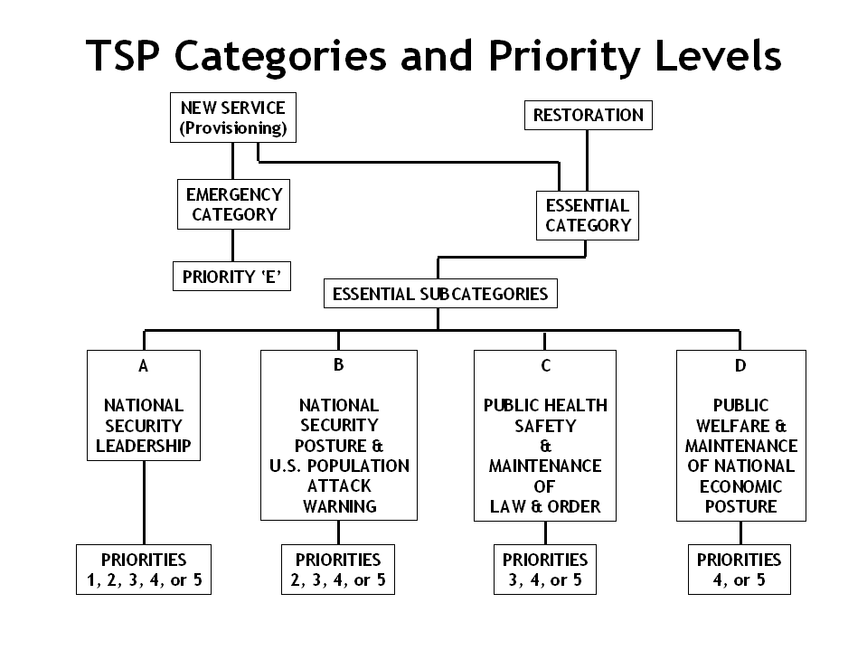
Figure 1 – TSP Categories, Subcategories, and Associated Priorities

VII. TSP ASSIGNMENTS

A. General

In requesting an assignment, consult FEMA CPG 1-18 and NCS 3-1-1. Be sure that the service is eligible and determine its priority level. The priority levels local governments request must follow TSP system categories, subcategories, and criteria. The TSP Authorization Code, a 12-character code that uniquely identifies each service, contains the TSP priority. For more detailed information go to the NCS, OPT home page at http://www.ncs.gov/tsp/. A copy of NCS 3-1-1 is available for review.

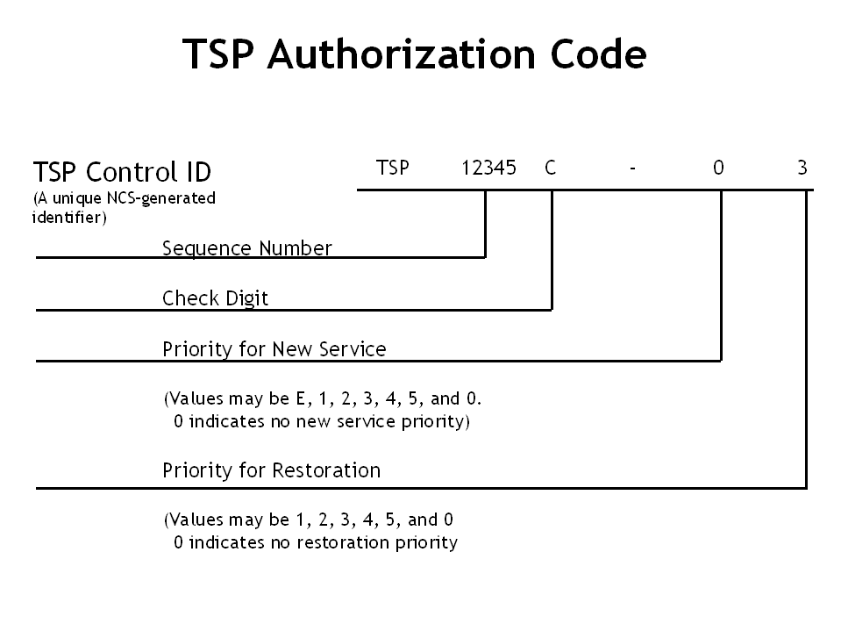

Figure 2. TSP Authorization Code

B. Criteria for Priorities

1. TSP assignments must be in one of the following subcategories.

- A - National Security Leadership - Not applicable to state and local government.

- B - National Security Posture and U.S. Population Attack Warning (Priorities 2, 3, 4, or 5). This subcategory is for services to enhance continuity of state and local government functions that support the federal government during national emergencies. Examples include control circuits for warning sirens and National Warning System terminals that are non-FEMA funded.

- C - Public Health, Safety, and Maintenance of Law and Order. This subcategory includes functions of population warning, law enforcement, and continuity of critical state and local government functions. It also applies to hospitals and distribution of medical supplies, critical logistic functions and public utility services, civil air traffic control, and critical weather services.

Examples could include local ACCESS lines, circuits for public safety radios, Public Safety Dispatch Center lines (dial up and data), hospital trauma center primary lines, and 9-1-1 public service answering points.

- D - Public Welfare and Maintenance of National Economic Posture. This subcategory includes distribution of food and other essential supplies. It also includes maintenance of financial systems, and prevention and control of natural hazard damage. Public agencies not qualified under the other subcategories may fall under this one.

2. The Vendor must be able to provide or restore the requested service.

VIII. RESTORATION PRIORITY

Generally, Vendors must restore telecommunications services having TSP restoration assignments first. After getting a restoration priority from NCS OPT; the User tells the Vendor what the priority is by a service order. As long as the assigned restoration priority remains in effect, the Vendor must restore it before any services without TSP coverage.

IX. NEW SERVICE ("PROVISIONING") PRIORITY

A new service does not normally need a TSP service priority. If Vendors cannot meet an emergency service requirement and there is a critical public safety requirement, local governments may request a priority. This requires Invocation official approval.

Example: A disaster makes the Sheriff's Public-Safety Dispatch Center unsafe for occupancy. The jurisdiction needs new lines installed at an alternate location immediately. The Invocation Official would authorize a TSP priority if the Vendor cannot provide service otherwise.

X. STATE OF WASHINGTON INVOCATION PROCESS

A. Invocation applies only to providing new services, not to restoration of existing service. A local government's first step in receiving a provisioning priority is to get authorization from the state's Invocation Official, which is the Governor or his delegated representatives, the Director, Military Department or Assistant Director, Emergency Management Division.

B. If the Invocation Official agrees to sponsor the provisioning and invoke TSP authorization, the approval will be conveyed to NCS OPT. The Service User then contacts the NCS OPT and requests an emergency provisioning Authorization Code.

XI. TSP REQUEST FORM AND APPLICATION PROCESS

A. Determine TSP requirement and prepare TSP Request Form per guidance in Appendix 3 for "restoration" or Appendix 4 for "provisioning". For more detailed guidance refer to FEMA CPG 1-18, Jul. 92 and NCS Manual 3-1-1, Jul. 90. NCS 3-1-1 and the request form (SF 315) may be found at http://www.ncs.gov/tsp/.

Mail completed TSP forms (SF 315) for requests for restoration priority to NCS OPT. Their address is:

Manager, National Communications System

ATTN: Office of Priority Telecommunications
701 South Court House Road
Arlington, Virginia 22204-2198

Provide a copy to the state Emergency Management Division. The address is:

State of Washington Military Department
Emergency Management Division
Camp Murray, Building 20
Camp Murray, Washington 98430-5122

- Except for Invocation requests for provisioning of emergency services, the state Emergency Management Division (EMD) does not approve TSP applications. EMD will provide any assistance or guidance in the preparation of a TSP request.

- For emergency provisioning requests which require Invocation Official authorization, the NCS OPT is available 24 hours a day, seven days a week. The NCS OPT receives the emergency provisioning request, normally by phone, followed by a TSP Request Form (SF 315) from the User. The NCS OPT verifies both the requirement and the invocation official's approval.

- After the Service User has received a TSP Authorization Code, the User gives it to a Service Vendor (either verbally or on a service order). For record, the user will provide the TSP Authorization Code to the state EMD. Figure 3 on the following page diagrams the application process explained above.

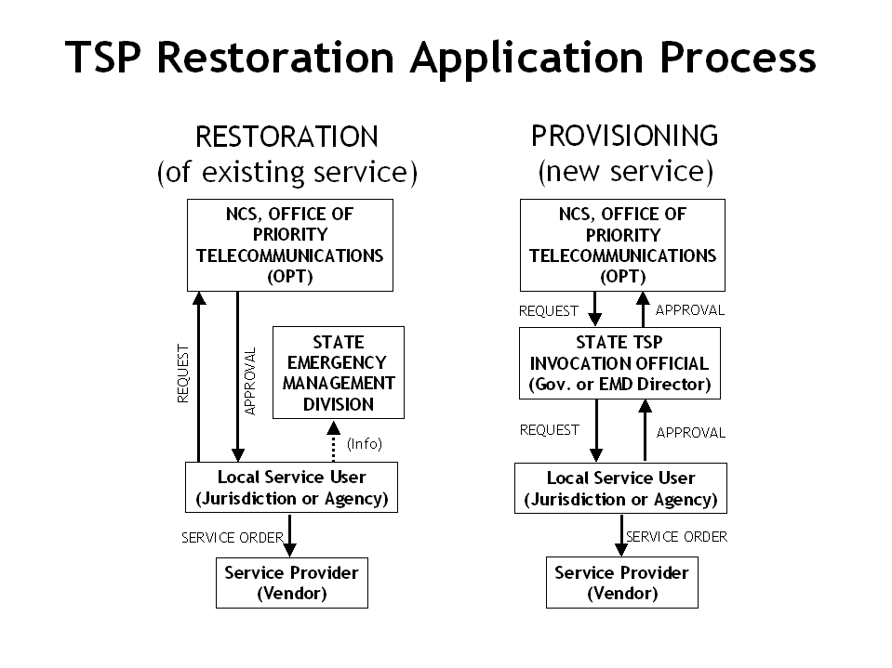

Figure 3 – Obtaining TSP Service

XII. CHECKLIST FOR STATE OF WASHINGTON TSP USERS

The following examples are typical of conditions that may be eligible for TSP coverage in Washington. Please refer to CPG 1-18 and NCS Manual 3-1-1 for a
full listing. In addition, Appendix 2 of this plan provides detailed analytical guidance on evaluating which circuits may need TSP coverage. Anyone requesting TSP service must remember that the Service User incurs the costs associated with acquiring TSP services.

A. Initial Considerations.

1. To fall into the "Emergency" category, a service must directly support or result from at least one of the following. (Note: Please request this only when the Vendor cannot install the service you need by the required date using normal procedures.)

a. State and local response to a Presidential, state, or local emergency.

Example: Establishing a government emergency operations facility due to a declared emergency.

b. Response to civil disturbance or disaster that has damaged facilities who’s interrupted operation is critical to public safety or emergency management.

Example: Moving a communications center that is uninhabitable due to an emergency.

c. These two conditions are eligible for priority "E" New Service ("provisioning"). The "E" will stay in effect until a Vendor provides service, but not more than 30 days. Generally speaking, the state Invocation Official will authorize priority "E" only for services that have been damaged or destroyed.

2. All other requests for service fall into the "Essential" category. Interruption of these services for a few minutes to one day would have serious adverse effects on the jurisdiction.

a. Communications needed to alert the public, maintain law and order, or maintain public health and safety during an emergency.

Example: New lines or circuits for sirens, horns, and speakers. A second example is temporary lines used to relay or coordinate a local health department's response to a hazardous spill incident. Use priority level "5", "4", or "3".

b. Telecommunications service needed to maintain public welfare and economic posture after an emergency.

Example: Communication services needed during an emergency to maintain public transportation routes. Use priority level "5" or "4".

B. Providing New Service: Approval Process for the State of Washington

1. Confirm that the Service Vendor cannot meet installation due date on time.

2. Contact the Emergency Management Division, at (360) 923-4931 (after hours 1-800-258-5990). Request authorization. Be ready to confirm vendor inability to meet required due date, vendor's name, contact, and telephone number. The specific type line or circuit requested, when needed, as well as the name and telephone number of the person making the request must be provided.

3. Upon approval by the Invocation Official, an Emergency Management TSP approval number will be assigned. (This number is for internal EM tracking only.) The approval will be conveyed to NCS OPT at (703) 607-4930 and a request for an emergency provisioning TSP Authorization Code will be made. The person/agency making the original request must follow up with a TSP Request for Service Users form (SF 315) which the user prepares and submits.

4. Information about the request will be logged. The tracking number, jurisdiction, contact name, phone number, date/time, and specifics of the request will be noted.

5. The service user gives the TSP Authorization Code to the Service Vendor either verbally or on a service order.

6. Shortly after getting a provisioning priority, the Service User will receive a blank NSEP Invocation Report (SF 320) from NCS OPT. The service user returns the completed report to NCS OPT as soon as possible after the Vendor provides service.

APPENDIX 1 - DEFINITIONS

Invocation of TSP NSEP Treatment

Invocation is the process a Service User follows to get new services. It applies only to new services, not to restoration. Invocation authority in Washington resides in the Governor, who has delegated this to the Director, Military Department or Assistant Director, Emergency Management Division.

National Communications System (NCS)

The National Communications System is a confederation of twenty-three federal departments, agencies, and entities. Established by Presidential Memorandum in 1963, it was reaffirmed by Executive Order 12472.

National Coordinating Center (NCC)

NCS established this joint telecommunications industry-federal government operation. It assists NCS in managing National Security Emergency Preparedness (NSEP) communications services and facilities.

National Security Emergency Preparedness (NSEP) Telecommunications Services

Government agencies use these services to maintain readiness or to respond to an event that could harm people, damage property, or threaten the security of the United States. These services fall into two specific categories, Emergency NSEP and Essential NSEP, with appropriate priorities.

National Security Emergency Preparedness (NSEP) Treatment

This means providing one communications service before others based on priority.

Priority Action

This means assigning, revising, revoking, or confirming a NSEP priority level. This is the responsibility of the Manager, NCS.

Priority Level

This is the priority of a NSEP telecommunications service. It specifies the order in which providing new service or restoring of the service is to occur.

Provisioning

This means the act of supplying new service to a User, including all associated transmission, wiring, and equipment. "Provisioning" is a TSP term that this plan replaces with the simpler and clearer "providing."

Public Switched NSEP Telecommunications Services

This describes services using public switched networks. Such services may include both inter-exchange and intra-exchange network facilities.

Restoration

This TSP-specific term refers to repairing telecommunication services that have experienced a service outage. The Vendor may do this by patching, re-routing, substitution of components or pathways, or other means.

Service User

This means an individual or organization supported by a telecommunications service for which a priority level exists.

Service Vendor

A Vendor is any entity (including common carriers and government organizations) that offers telecommunication equipment, facilities, or services.

Telecommunications Services

For TSP purposes, these services include transmission, emission, or reception of signals, signs, writing, images, sounds, or intelligence of any nature. The method of transfer may be by wire, cable, satellite, fiber optics, laser, radio, visual, or other electronic or acoustically coupled means, or any combination thereof.

APPENDIX 2 - DETERMINING TELECOMMUNICATIONS SERVICE PRIORITY REQUIREMENTS FOR EMERGENCY COMMUNICATIONS SYSTEMS

Background

Costs associated with TSP make it too expensive to apply to every line. Still, state and local jurisdictions using telephone systems as a significant part of their emergency management functions should evaluate their need to participate in TSP. This evaluation will reveal whether sufficient backup systems and other counter-measures exist to ensure continued management of emergency operations. It also will show which specific circuits need to be under TSP.

Scope and Approach

This document provides guidance in evaluating whether telephone systems supporting emergency management should be part of the TSP system. The guidance uses a three-step process. First, check the system's individual components, looking at each in depth and not making any assumptions. Next, assess potential threats to the system and probable consequences. Finally, identify measures to minimize the threat or mitigate the consequences. (Many of these measures will not involve TSP. Indeed, their use may eliminate the need for TSP.)

Step 1 - Evaluation

The communications manager needs a thorough understanding of the telephone system. This includes identifying all elements of the system and understanding their interrelationships. Elements include all entities linked through the system. Examples include police, fire, and medical resources, as well as the Emergency Operations Center and the jurisdiction's political leaders. Having identified the elements, the manager must look at the network linking them together. Of course, the manager must have a conceptual understanding of the network's function. However, the analysis needs to be in depth, identifying each physical component. (Components include circuitry, local offices, repeaters, switches, cross-connections, microwave dishes, power sources, and any other hardware or software involved in the system.)

In completing the analysis, the manager needs to work with the service provider(s) or vendor(s), who can provide information on network components and facilities. However, the vendor may consider some information proprietary. If so, the vendor may be unwilling to provide complete responses to some questions.

To conduct a thorough evaluation of the system, managers need to ask specific questions.

1. How many vendors provide service and for which equipment? Look at both the network and at customer owned equipment. Managers also should investigate reselling of long distance service and other sub-contracts.
2. What are the common points of failure? Which facilities, equipment, or systems will affect other portions of the system if they fail?

3. Which local offices serve each segment of the network? If all segments come from the same office, this may be a single point of failure.

4. What facilities or equipment link different elements?

5. What types of facilities or equipment represent each segment of the system? (Example: copper wire or fiber cable, overhead or buried cable, microwave or landline, etc.)

6. How many possible points of failure exist with each component of the system?

7. Which components of the system have the highest point of failure?

- What network management tools monitor the components of the network and identify problems?

In addition to assessing the network, the manager needs to assess contractual agreements with the vendors. This assessment must include a review of service agreements to determine existing measures to combat potential failures in any network element. Typical questions include the following.

- What other emergency service systems exist in the area and how do they rank compared with the emergency communications system? What other services will compete for restoration during a widespread outage?

10. What restoration arrangements exist in the contract? How does the contract specify response?

11. Is there a strong working relationship among the service provider(s) and the network manager? If more than one provider, is there a strong working relationship among the service providers?

Step 2 - Assess Potential Threats

This step's purpose is to assess the vulnerability of the network. System managers should determine potential threats to the system as a whole, as well as to the individual components. This analysis should be exhaustive, identifying all possible threats to the system, regardless of the severity or the cause. Then rank the threats from the most likely to the least likely to occur.

Use the following questions to evaluate potential threats to the system. The aim is to set priorities by focussing on risk, which includes both probability and consequences.

1. What potential natural disasters threaten your system? (Be specific and include a range from minor to severe threats.)

2. What technological hazards pose a threat to your system?

3. What potential network failures threaten the functionality of the system?

4. Which components of the system would each potential threat affect?

5. Which components of the system are most vulnerable to the potential threats?

6. What are the effects on the system's functionality when a particular component is inoperable?

Step 3 - Identify counter measures to mitigate threats

Step 3 addresses the methods employed to counter the potential threats to the system or mitigate their effects. This step will assist system administrators in rating the survivability of each component identified in the first step. Evaluate the system's backup equipment, plans and procedures in cooperation with the service providers. Methods for mitigating the effects of the potential threats should be addressed for each component.

Consider the following questions when identifying counter measures.

1. What contractual restoration procedures are in effect for each component of the system? (Review service agreements for customer-owned equipment, as well as subcontractors to the principal vendor. Consider again the response time elements of these service contracts.)

2. What alternative services are available to combat potential threats to each segment of the system? (Samples include alternate routing, dual homing, custom calling features, foreign exchange, etc.)

3. Are radio, microwave, or cellular systems employed as backups to the system?

4. Which locations have working, regularly load-tested backup power sources?

5. Is standby equipment available at each site within the system? (This is a key question. If a component or circuit isn't important enough to provide backup, it probably doesn't warrant TSP.)

Application of TSP based on results

The methodology helps assess whether sufficient methods are available to alleviate the effects of potential threats on emergency service communications systems. It provides system managers with a basis for identifying vulnerable areas in the system. Following this methodology will help determine whether participation in the TSP System is warranted. In general, TSP is not appropriate for all segments of the network. The Federal Communications Commission never intended TSP to provide total coverage. However, addressing each component of the system separately might identify areas where a TSP assignment would be prudent.

Based on the results of the evaluations in the methodology, TSP might be applicable to the following situations:

- Facilities within the system use more than one service vendor.

- Network components have single points of failure.

- Vendor relations are unsteady or questionable, or past vendor service has been poor.

- Segments of the service where diversification alternatives are limited or insufficient.

System administrators should use the results of the methodology to determine areas where TSP would be helpful. Further, good vendor relationships combined with a high visibility system might mean timely response to failures without a TSP assignment. Regardless of the mitigation method one ultimately chooses, this methodology will assist in determining the survivability of your system.

APPENDIX 3 - REQUEST FOR "RESTORATION" PRIORITY SERVICES

I. GENERAL

This appendix provides information on the preparation and processing of a restoration request. An important feature of the TSP System is that, with certain exceptions, vendors are required to restore services with TSP restoration assignments before telecommunication services without such assignments. After obtaining a restoration priority assignment from the NCS TSP Program Office, the user conveys the priority assignment to the vendor on a service order. As long as the assigned restoration priority remains in effect, the vendor is required (within the rules established by the FCC) to restore that service before services without TSP assignments, and before TSP services with a lower priority. Once a restoration priority assignment is obtained, it remains in effect for three (3) years or until revoked, changed, or revalidated at the request of the user.

A copy of the TSP Request Form, Standard Form (SF) 315 is provided at Appendix 6. Instructions for completing the form are provided in the following paragraphs. The form and complete instructions can also be found at the NCS home page at http://www.ncs.gov/tsp/

II. Instructions for Completing the SF 315

Item 1: Action Requested: For Item 1 of SF 315, select the type of action requested.

A. Initial Priority - New Service: Applicable when submitting a TSP request for a new service.

B. Initial Priority - Existing Service: Applicable when submitting a TSP request for an existing service that does not have a TSP assignment.

C. Change to Service, Priority, or Information about Service: Applicable when submitting a change to a current TSP assignment.

D. Revoke Service: Applicable when submitting a TSP request to revoke a TSP assignment. Revocation must be submitted when TSP is no longer required.

F. Revalidate Service: Applicable when submitting a request to revalidate a TSP assignment every 3 years.

Item 2. Date Service Required. Enter the date (mm/dd/yy) service is required.

Item 3. New Service User ID. Any unique identifier used to recognize this service. Vendor circuit ID may be used as the User ID.

Item 4. Service Identifiers. If Item 1 contains an "A" or "B", leave this item blank. If Item 1 contains a "C", "D", or "F" and there is a TSP assignment, enter the TSP Assignment Code in item 4a; otherwise enter the previous service user service ID in item 4b.

Item 5. Service Profile. See Appendix 5 for selecting appropriate Service Profile elements. The Service Profile describes the attributes of a service that are under control of a user. Determine which profiles (e.g. A3, B1, F2, etc.) apply to the service. If none apply, enter NA.

Item 6. Restoration Priority Information. If Item 1 contains a "D" or "F", leave this item blank. If Item 1 contains an "A", "B", or "C" (for change to priority) enter data as noted below.

a. Subcategory under Which Service Qualifies for Priority Treatment. Enter B, C, or D. (Note: Subcategory A is not applicable to state and local governments.) See page 4 of this document for subcategories.

b. Criteria under Which Service Qualifies. Enter a number from 0 to 9. See CPG 1-18, Jul. 92, Chapter 4, subparagraphs 4-3c(2) through (4) for criteria.

c. Restoration Priority Requested. Enter 2, 3, 4, or 5. (Note: Priority 1 is not applicable to State and local governments.)

Item 7. Provisioning Priority Information. Leave this item blank.

Item 8. Service User 24-hour Point-of-Contact. This may be left blank. If used, enter the following data:

a. Title or Name.

b. Daytime Telephone Number. Enter area code and phone number.

c. Off-hours Telephone Number. Enter area code and phone number of nonduty hours telephone number.

Item 9. Supplemental Information. Use this item to expand or continue entries contained in Item 5.

Item 10. Service User. Enter "B" for a state government activity or "C" for a local government activity.

Item 11. Service User Organization. Enter the organization's identification, such as Washington State Patrol or King County PUD.

Item 12. Major Network Information. If this service is part of, or uses, a major network such as the Public Switched Network (PSN), enter the network acronym. If there is no acronym, enter the network name. Otherwise, leave item blank. Entries may not exceed 24 characters in length.

Item 13. Service User Point-of-Contact.

a. Title or Name. Enter the name of the person (or office) responsible for and/or who knows the most about this service. All notices, information, or questions regarding this service will be directed to this POC.

b. Organization. Enter POC's organization (e.g. County Sheriff)

c. Mailing Address. Enter POC's mailing address.

d. City/State/Zip Code. Enter POC's city, state, and zip code.

e. Telephone Number. Enter POC's telephone number.

f. Facsimile Number. Enter POC's facsimile number.

Item 14. TSP Requestor Information.

a. Name. Enter name of person preparing form. May be same person identified in Item 13.

b. Organization. May be left blank if same as Item 13.

c. Telephone Number. May be left blank if same as Item 13.

d. Signature and Date. This form must be signed and dated by the requestor.

III. Submission and Approval Process

- Submit completed SF 315 to the Manager, National Communications System (NCS) at the following address:

Manager, National Communications System
Attn: Office of Priority Telecommunications
701 South Court House Road
Arlington, Virginia 22204-2198

For information purposes only, provide a copy to the Washington State Military Department, Emergency Management Division at the following address:

State of Washington Military Department
Emergency Management Division
Camp Murray, Building 20
Camp Murray, Washington 98430-5122

B. Upon receipt, the NCS OPT will review and approve. For clarification or additional information, NCS OPT will contact the requestor as needed. If approved, NCS OPT will assign a TSP Authorization Code.

IV. Actions upon Receipt of a TSP Authorization Code

Upon receipt of a Priority Action Notice from NCS OPT; prepare a service order, indicating the TSP Authorization Code, and submit it to the vendor. This requirement applies not only to initial assignment, but also to changes of an assigned priority and revocations.

If the prime vendor makes arrangements with one or more additional vendors to provide portions of the service, the prime vendor is responsible for providing the other vendors with the TSP assignment.

APPENDIX 4 - REQUEST FOR "PROVISIONING" SERVICES

I. GENERAL

This appendix provides information on the preparation and processing of a provisioning request. A provisioning priority is not routinely required for a TSP service. (Normally, the user requests only a restoration priority.) If the user has been able to adequately plan for the service, the vendor can normally meet the service due date following normal business procedures. It is the responsibility of each user to request a provisioning priority only after other avenues for obtaining the service have been exhausted. Users should not request a provisioning priority under the following circumstances:

A. Make up for time lost because of inadequate planning.

B. Activate service for which required CPE (customer premises equipment) (e.g. government-furnished modems, or other terminal equipment), or network facilities will not be available by the user's service due date.

C. Facilitate the normal relocation or rearrangement of existing service (e.g. internal organizational moves) unless required to support the start of a new TSP service.

D. Disconnect existing service unless required to support the start of a new TSP service.

II. Process for Requesting "Provisioning" Services

A. Determine requirement. If provisioning (initiation) of a new service is required at the earliest possible time, the required service supports at least one of the functions indicated under Subcategory B (see page 3, paragraph V.), and the vendor cannot provide the service as soon as needed, Emergency service may be requested. If the provisioning of new service is required by a specified date, the required service supports one of the functions under Subcategories B, C, or D (see page 3, paragraph V.), and the vendor cannot provide the service by the specified date, Essential service may be requested. Does the user have a critical requirement for provisioning? Has the user contacted the vendor? Has the vendor indicated that the service cannot be provided at the earliest possible time (Emergency) or by the specified due date (Essential)? If the answers to these three questions are YES, proceed with the TSP provisioning process.

B. Request Invocation. The following procedures are used to obtain invocation authorization:

1. Contact (via voice and/or facsimile) the Governor's designated Invocation Official. For the State of Washington, that official is the Director, Military Department or Assistant Director, Emergency Management Division.

a. Business Hours (8-5): (253) 512-7034
After Hours/Weekends: 1-800-258-5990

b. Facsimile: (253) 512-7203

2. State the requirement, explain the circumstances, and request invocation.

3. After invocation is authorized and upon receipt of the TSP Authorization Code, prepare as soon as possible, the SF 315.

4. Notify the vendor of receipt of TSP Authorization, prepare and provide the vendor a service order indicating the TSP Authorization Code. Also, provide the vendor the name, title, and telephone number of the Governor's designated Invocation Official.

III. Instructions for Completing the SF 315

Item 1. Action Requested. Enter an "A" (initial priority for a new service).

Item 2. Date Service Required. Enter the date (mm/dd/yy) service is required.

Item 3. New Service User ID. Any unique identifier used to recognize this service. Vendor circuit ID may be used as the User ID.

Item 4. Service Identifiers. Leave item blank.

Item 5. Service Profile. See Appendix 5 for selecting appropriate Service Profile elements. The Service Profile describes the attributes of a service that are under control of a user. Determine which profiles (e.g. A3, B1, F2, etc.) apply to the service. If none apply, enter NA.

Item 6. Restoration Priority Information. Leave item blank.

Item 7. Provisioning Priority Information.

a. Subcategory under Which Service Qualifies for Priority Treatment. If this is an Emergency request (normally the case); enter an "E". If this is an Essential request, determine the subcategory. See page 4 for the subcategories. (Note: Subcategory A is not applicable to state and local governments.)

b. Criteria under Which Service Qualifies. If this is an Emergency request, enter a number 2 or 5. See CPG 1-18, Jul. 92, Chapter 4, subparagraph 4.3a for criteria. If this is an Essential request, enter a number from 0 to 9. See CPG 1-18, Jul. 92, Chapter 4, subparagraphs 4-3c(2) through (4) for criteria.

c. Provisioning Priority Requested. If this is an Emergency request, enter an "E". If this is an Essential request, enter a 2, 3, 4, or 5. (Note: Priority 1 is not applicable to State and local governments.)

d. Invocation Official's Name. Enter the Governor's name or name of the Governor's designated invocation official.

e. Invocation Official's Title. Enter the Governor's title or the title of Governor's designated invocation official.

f. Telephone Number. Enter the telephone number (area code and number) of the Governor's designated invocation official.

g. Has the Invocation Official Authorized This Action? Enter a "Y" if invocation has been authorized. This form should not be prepared if invocation has not been authorized.

h. Service Location(s). Enter the street address, building number, room number, etc., of the service location.

i. Prime Vendor Point-of-Contact for Emergency Provisioning. Enter the company, name, and telephone number of the prime vendor's POC for provisioning. Include information for both emergency and essential provisioning requests.

j. Is Order in Progress? Enter a "Y" if the vendor has been notified that this provisioning request is being submitted. Otherwise, enter a "N".

Item 8. Service User 24-hour Point-of-Contact.

a. Title or Name.

b. Daytime Telephone Number. Enter area code and phone number.

c. Off-hours Telephone Number. Enter area code and phone number of nonduty hours telephone number.

Item 9. Supplemental Information. Use this item to expand or continue entries contained in Items 5 and 7c. Also provide the following:

a. Description of Service. Enter a brief description of the service required.

b. Special Service Considerations. List special service considerations (e.g. circuit or service data rate, conditioning requirements, unique equipment requirements, cellular requirements.)

c. Identifiers. Enter circuit number and other identifiers to the extent known.

d. Permanent/Temporary. Indicate whether the service is to be permanent or temporary.

e. On-site POC. Identify an on-site POC. If the on-site POC is the same as the 24-hour POC, so indicate.

f. Vendor Contact. Indicate whether an attempt was made to expedite the process with the normal vendor contact.

g. Funding. Enter the name, title, and organizational address of the person actually obligating the user to fund the service.

h. Work Progress. If an order for service is already in progress, enter the date on which the user ordered the service.

Item 10. Service User. Enter "B" for a state government activity or "C" for a local government activity.

Item 11. Service User Organization. Enter the organization's identification, such as Washington State Patrol or King County PUD.

Item 12. Major Network Information. If this service is part of, or uses, a major network such as the Public Switched Network (PSN), enter the network acronym. If there is no acronym, enter the network name. Otherwise, leave item blank. Entries may not exceed 24 characters in length.

Item 13. Service User Point-of-Contact.

a. Title or Name. Enter the name of the person (or office) responsible for and/or who knows the most about this service. All notices, information, or questions regarding this service will be directed to this POC.

b. Organization. Enter POC's organization (e.g. County Sheriff)

c. Mailing Address. Enter POC's mailing address.

d. City/State/Zip Code. Enter POC's city, state, and zip code.

e. Telephone Number. Enter POC's telephone number.

f. Facsimile Number. Enter POC's facsimile number.

Item 14. TSP Requestor Information.

a. Name. Enter name of person preparing form. May be same person identified in Item 13.

b. Organization. May be left blank if same as Item 13.

c. Telephone Number. May be left blank if same as Item 13.

d. Signature and Date. This form must be signed and dated by the requestor.

IV. Submission Process

- Submit the completed SF 315 to the Manager, National Communications System (NCS) at the following address:

Manager, National Communications Systems
Attn: Office of Priority Telecommunications
701 South Court House Road
Arlington, Virginia 22204-2198

For information purposes, provide a copy to the State Emergency Management Division. Address is:

State of Washington Military Department
Emergency Management Division
Camp Murray, Building 20
Camp Murray, Washington 98430-5122

B. Upon receipt, NCS OPT will review and file with the Invocation request.

V. Actions of Vendor upon Receipt of TSP Authorization and Invocation

The vendor, upon receipt of the service order, must respond promptly to the invocation. The vendor may contact the Governor, or designated Invocation Official, or NCS OPT to verify the invocation or resolve questions regarding the TSP assignment. Under no circumstance may the vendor delay the processing of Emergency TSP request to question its validity.

APPENDIX 5 – SERVICE PROFILE

ELEMENTS PROVISIONING RESTORATION

Customer Premises Equipment
On-site and on-call maintenance support A1
Spare equipment back-up A2
Equipment & site preparation by user A3

Customer Premises Wiring
On-site and on-call maintenance support B1
In-house circuit segments by user B2

Operations
24 hours per day or hot stand-by C1 C1
Other (explain in Item 9, SF 315) C2 C2

Technical Control Facility
24 hour fault determination D1 D1
Automatic alarm of service loss D2

Service Testing E1

First Service and Route Diversity
A first service F1 F1
Route diversity for other TSP F2 F2
Other (explain in Item 9, SF 315) F3

Facility and Site Access
Access 24 hours per day G1 G1’
Access at prearranged time G2 G2’
Access by next business day G3
Other (explain in Item 9, SF 315) G4

Note: G1’ and G2’ have priorities of 2 - 4, not 2 - 5

